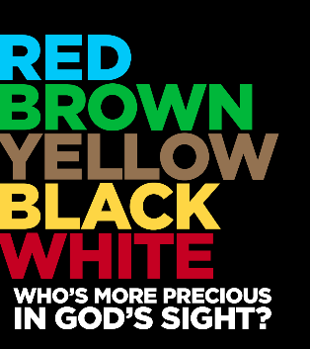
Red and Yellow, Black and White: Why Are Some More Precious?
A Conversation on
Race and Christian Faith

February 1, 2018 @ 6:30-8:00pm
Cody’s Smokehouse BBQ

How we think about race continues to be a hot button issue in our nation and in our churches. We’re going to jump right in to this difficult topic for our first session of Brewed Theology. The following are some suggested resources for you to review that will enhance our discussion. However, if you cannot get to all or any of them, our time together will still be fruitful.

First Step: Read the following brief passages of Scripture (5 minutes)
Acts 2:1-8
Context: Jewish people from many lands have gathered in the city of Jerusalem for the Jewish festival of Pentecost. At this same time, Jesus’ disciples are dramatically given the gift of the Holy Spirit. All persons hear the Good News in their own languages.

Galatians 3:25-29
Paul is writing to one of his early mission starts to address an early conflict. Should new Christians who were not Jewish have to obey Jewish laws (circumcision) to become part of the community? Or is God doing a new thing with through the Risen Christ and the power of the Holy Spirit? Paul does some radical bridge-building with these words.

Step Two: Read the following two articles about race and faith by two well known contemporary Christian leaders who come from different traditions. (5 minutes)

Check out this Interview with Fr. Richard Rohr

Read this brief article by Jim Wallis

Step Three: Watch or read this TED Talk (18 minutes or 10 minutes)
Vernā Myers is a diversity consultant who works within large workplaces and institutions to break down barriers of race, ethnicity, gender and sexual orientation. She intends a “low-guilt, high responsibility” method. Watch the video or read the transcript.

Extra Credit: Take the Test

Ever wonder what imbedded biases you might be carrying? Whether you like the results or not, there’s an app for that (more like a quiz, actually)! Developed at Harvard University, “The Implicit Association Test” (IAT) measures attitudes and beliefs that people may be unable to perceive or report. Instructions: When you get to the Preliminary Information page, click on the words, “I wish to proceed” at the bottom. On the following page, scroll down to the “Race IAT button of the column and begin the quiz. To get started, click here.

